Gathering Information Realtime and Anywhere (GIRA) Using an ANN Algorithm

Aciek Ida Wuryandari*1 and Rifki Wijaya*2

\**School of Electrical Engineering and Informatics*

*Bandung Institute of Technology, Ganesa Street 10, Bandung 40132, Indonesia*

[1aciek@lskk.ee.itb.ac.id](mailto:1aciek@lskk.ee.itb.ac.id)

[2rifkiwijaya@gmail.com](mailto:2rifkiwijaya@gmail.com)

Abstract**— By using mobile technology applications and content based image retrieval are integrated with Location Based Services, created an app called "Actual Mobile Application for Tourist Guide" that can be used as a guide in realtime and actual tourists and can also be used as an alternative media for the promotion or advertisements from companies engaged in tourism, such as hotels, restaurants, or travel agent. This application has the potential to be a killer application in the world of mobile applications. The handset is a smart phone that is used with the Windows Phone OS. On the handset will be there making frames for processing in realtime using the SIFT algorithm is then processed using an algorithm ANN (Artificial Neural Network) to finally matching it with the existing ANN results on mobile phones as well as on the server. First Mobile will detect its presence by using GPS. Once detected the place, it will be given training outcomes data from the database to the phone, according to the radius of the place of its existence..**

***Keywords*— mobile application, content-based image retrieval, Location Based Services, smart phone, realtime.**

1. INTRODUCTION

Lately a lot of research in the field of mobile application along with the high computing capacity of mobile communication devices. Application of mobile technology enables a mobile handset equipped with a camera and enough computing ability to get information in real time from a real object in nature, in which it is commonly called virtual content can be combined with real objects in nature that becomes the target of mobile applications, such as virtual content can be placed on top of the layer image of the object being targeted application of mobile applications.

By using mobile technology applications and content based image retrieval are integrated with Location Based Services, created an app called "Actual Mobile Application for Tourist Guide" that can be used as a guide in realtime and actual tourists and can also be used as an alternative media for the promotion or advertisements from companies engaged in tourism, such as hotels, restaurants, or travel agent. This application has the potential to be a killer application in the world of mobile applications. The handset is a smart phone that is used with the Windows Phone OS. On the handset will be there making frames for processing in realtime using the SIFT algorithm is then processed using an algorithm ANN (Artificial Neural Network) to finally matching it with the existing ANN results on mobile phones as well as on the server. First Mobile will detect its presence by using GPS. Once detected the place, it will be given training outcomes data from the database to the phone, according to the radius of the place of its existence.

Artificial Neural Network (ANN) is a network of a group of small processing unit is modeled by a neural network of human behavior. Algorithms ANN was born from the idea of ​​a psychologist Warren McCulloch and Walter Pitts in 1943 explaining how the neural network with the electronic network.

In the world of seismic exploration, is quite popular ANN algorithms applied, including for noise identification, wavelet estimation, rate analysis, analysis of shear wave, auto tracking reflector, predictions hydrocarbons, reservoir characterization, and others.

ANN algorithm is a simple configuration can be described in the figure below.

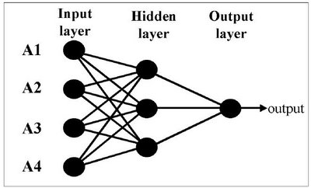

Fig. 1 Courtesy Hampson Russell

From the picture above it is apparent that the basic principles of ANN are a number of parameters as input layer is processed in such a way in the hidden layer (multiplication, addition, division, etc.), then processed again in the output layer to produce an output.

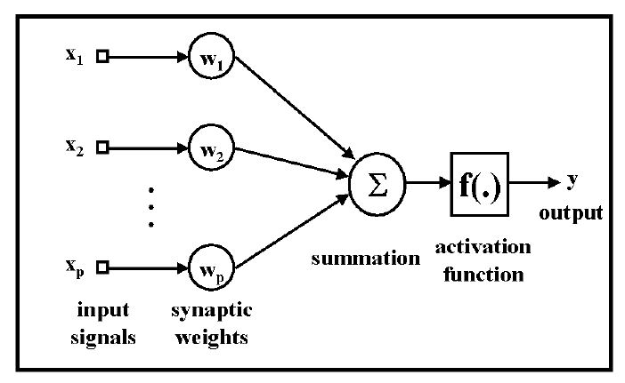

Fig. 2 Courtesy Hampson Russell

The picture above shows an example of the application of ANN to seismic data, say there are several inputs (input) as impedance (x1), reflection strength (x2), instantaneous frequency (x3), ... etc., which will be used to predict reservoir porosity as output (output). In simple porosity reservoir will be obtained by multiplying each sample of the input data by a weighting factor (weight) and then summed. Furthermore, the sum becomes the input to the activation function that will ultimately result in porosity parameters.

1. BACKGROUND

Research conducted has a goal to create an app called Actual Mobile Application for Tourist Guide can serve as a guide in realtime and actual tourists and can also be used as an alternative media for the promotion or advertising of companies engaged in tourism, such as hotel, restaurants, travel agents and others.

Actual product Mobile Application for Tourist Guide is a product that is prepared to help the tourists who are traveling, both foreign and local tourists, so the interface designed usability goals should include aspects such as effective, efficient and easy to use, and aspects of the user experience goals as satisfying, enjoyable fun, helpful and others.

Actual Mobile Application for Tourist Guide will be used as a medium of information that will be used by the users to find the information that is owned by a tourism object, building, etc., as we can see in the image below.

Other information can be obtained is the location of buildings or rooms in a building that was targeted. Besides these applications can also be used as an alternative medium for promotion or advertising object through feature recognition owned this application. As can be seen in the figure below.

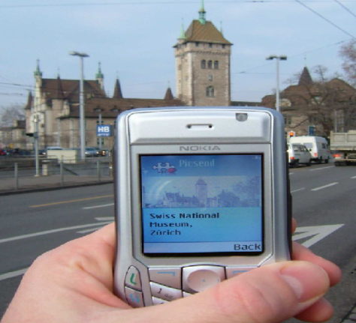

Fig. 3 Implementation markerless augmented reality for the introduction of the building

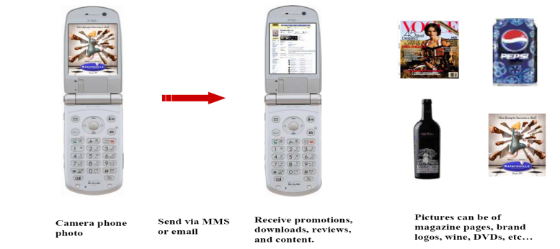

Fig. 4 Object recognition for advertising purposes

The results of this study have the potential to be commercialized. A person who needs the information associated with the image in his capture (with a camera), will send the images to your provider (to get full information about the images in his capture). Surely these people must pay, with pulses at HP was reduced. When he got an answer from the provider, advanced communications can occur between provider and himself repeatedly. Every time he requested information, then pulse in his HP will be reduced.  
Apart from that, hotels, gas stations, restaurants and anything related to the tourism sector, whose efforts to be accessed by software, of course, must be paid, such as advertising in other media.

1. ANALYSIS AND SYSTEM DESIGN

The basic requirements are an absolute must have to try this system are as follows.

* Computer server.
* Mobile operating system (OS) windows phone.
* Connection to the server using a Wi-Fi phone.
* The object that we want to know the information.
* Database objects following information.

Requirement specification features are

1. validate LBS based BTS nearby;
2. captures images from a camera and implements HP Difference of Gaussian;
3. perform rotation invariant, scale, and illumination changes in the image;
4. generate key descriptor of the image captured by the camera.;
5. do image matching algorithm NNS;
6. produce XML as information about nearby objects;
7. to review of the buildings highlighted by a camera phone;
8. display public places that are around a highlighted item; Public venues such as gas stations, hotels, restaurants;
9. implement augmented reality technology which means it can translate the intended object image with another image.

Actual Mobile Application for Tourist Guide is a mobile application that uses network GPRS/3G/HSDPA in connecting data. This application uses a client-server application architecture, where the client application is installed on a mobile communication device. On the client application, the functionality of which is owned as follows:

* highlight the target image;
* image recognition process to generate the number of key point descriptor;
* ANN results matching process on the handset or on the server;
* display information corresponding to the target image.

As for the server side, the application is installed on one or more application servers are placed in a co-location data center located in either the mobile operator or third parties that provide data center services. Owned application functionality on the server side are as follows:

* the process of image matching using ANN algorithm and its variants;
* generate the SQL file to perform the query information from the target image to the database server;
* generate an XML file that contains information corresponding to the target image.

The system architecture of the application can be seen in the following figure.

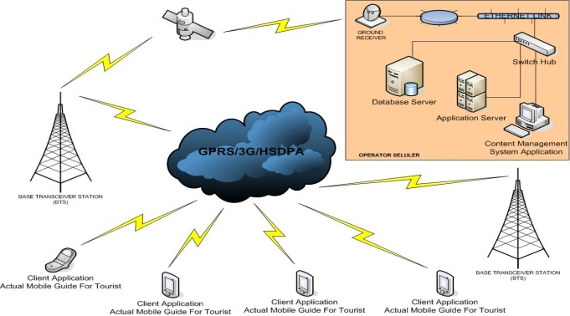

Fig. 5 Architechture Actual Mobile Application for Tourist Guide

Of the system architecture in the picture above, this application can be grouped into four major subsystems of the architecture in the system, namely:

* The mobile communications (mobile)
* Database Server
* Application Server
* Content Management System Application

The interaction of the four subsystems can be seen in the picture below.



Fig. 6 Diagram of interactions between subsystems

The interaction of the four subsystems has its own benefits. Content Management System, is useful to increase the number of images and information in the database, so that the tourist can use the free application and image taken with the mobile phone is always available information.

For Application Server serves to bridge between the client and the server. Application Server assigned to a query to the database and insert images and information into a database. Application Server is also used to change the image into a number.



Fig. 7 Logical design Actual Mobile Application for Tourist Guide

**Data Specification**

In general, the data stream is divided into two parts, as follows.

1. The flow of data on the client

Is the data involved in the process of image acquisition object, SIFT feature extraction algorithm, ANN, matching and display.

2. The flow of data on the server

Is the data involved in the process of client-server connections, content retrieval from database and image training.

Some of the data involved in the system are as follows.

1. LBS Parameter: Data is longitude and latitude of the current user's position. Data is provided by the Local Base Service (LBS) of the operator.
2. Image data: image of the form of the camera to be addressed detailed information.
3. Keypoint Descriptor: as dots on the image that is a unique part of the image and used as a comparison between the images of one another.
4. Detail object information: is the data output system, which is an explanation of the object image that is being highlighted.
5. Network parameters: some data is used as a parameter to identify the client, can include phone numbers, mobile phone or other UID



Fig. 8 State diagram Actual Mobile Application for Tourist Guide

1. iMPLEMENTAtion

Products "Actual Mobile Application For Tourist Guide" is a product that is prepared to help the tourists who are traveling, both foreign and local tourists, so the interface designed usabilty goals should include aspects such as effective, efficient and easy to use, and user aspects experience goals such as satisfying, enjoyable fun, helpful and others. Graphical User Interface to the product "Actual Realtime Mobile Application For Tourist Guide" can be seen below.









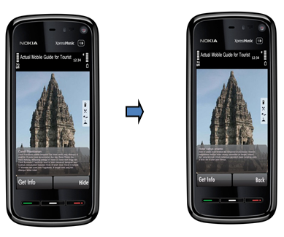

Fig. 9 Interface Actual product Mobile Application for Tourist Guide

External interfaces in these products involves a network device Base Transceiver Station (BTS), which serves as the transceiver to connect with all the handset on and in coverage (cell) and run the application Actual Mobile Application for Tourist Guide. Additionally Base Transceiver Station (BTS) also communicate with the server side of the product Actual Mobile Application for Tourist Guide. So with the help of GPS, the handset and server side can be interconnected. Actual product Mobile Tourist Guide Application for use in connecting GPRS/3G/HSDPA network data.

Fig. 10 External interface



Fig. 11 The flow of data on the components and subsystems client application



Fig. 12 The flow of data and subsystem server application component

The flow diagram (flowchart) subsystem of image matching can be seen in the following figure.

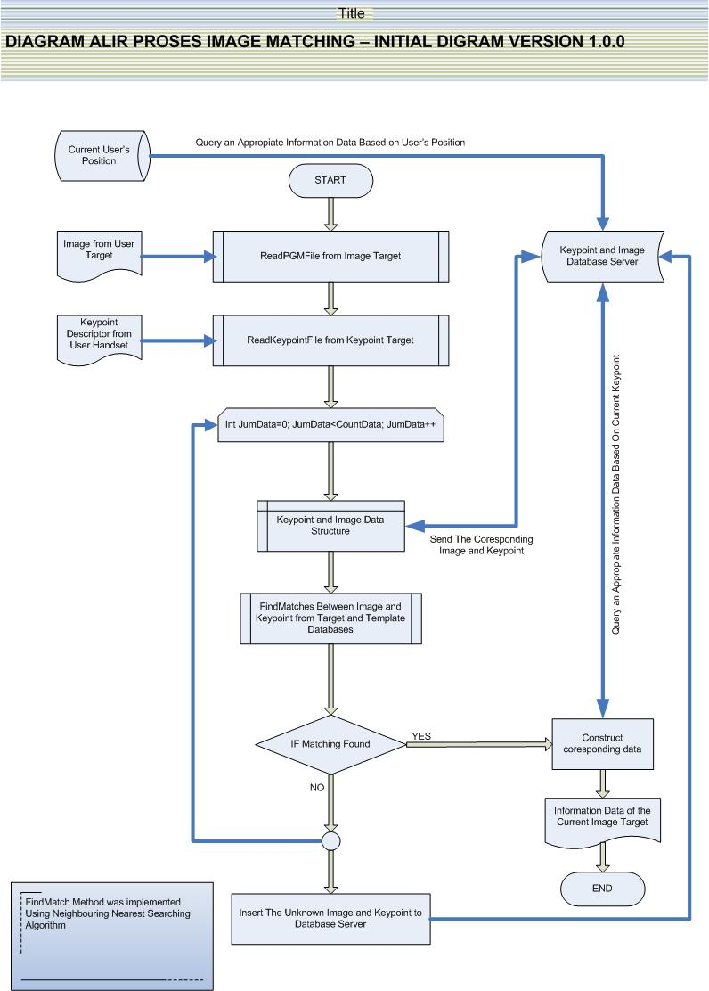

Fig.13 Flowchart of image matching process

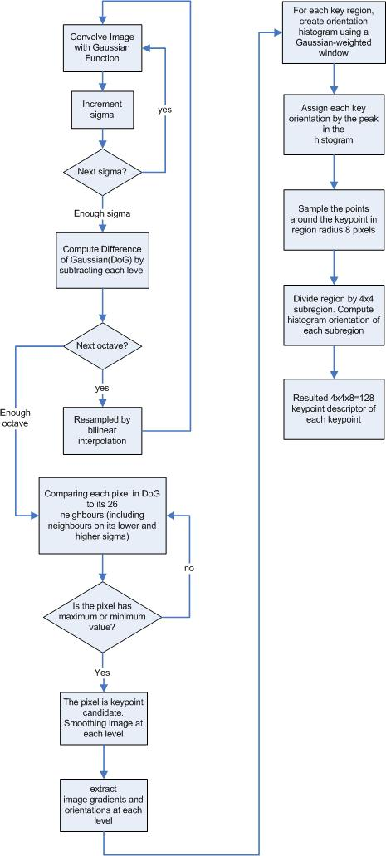

Fig. 14 Flowchart SIFT

Achievement results in the first half are manufacture specification framework application modules that cover data applications, flowchart, GUI, software design specification, data specification, and system architecture.

Studies have been done, resulting in the algorithm literature as a SIFT matching algorithm along with the data object previously mentioned specifications. Prepare specifications application framework, makes modeling Unified Modeling Language (UML) has been performed. The next activity is to build modules CBIR application is currently running, so it can’t be shown the results.

1. CONCLUSION

Now, Actual Mobile Guide Application for Tourist developed using ANN algorithm to its matching process. It is hoped the matching process like this, it will cause the process is done on the client side can be run more quickly and accurately. Compared with the application that had been made previously, which uses algorithm to Nearest Neighborhood its matching process.

ACKNOWLEDGMENT

Thanks to School of Electical Engineering and Informatics, Institut Teknologi Bandung as the organizers ICSET 2012 that has given us the opportunity to contribute.

ReferenceS

[1] Aciek Ida Wuryandari and Ary Setijadi Prihatmanto, Gathering Information Realtime and Anywhere(GIRA), *Proceeding of the 2011 International Conference on Electrical Engineering and Informatics* (ICEEI 2011), IEEE, Bandung, Indonesia, 17 – 19 July 2011.

[2] Braitner, Michael, Market Development of Mobile Device Classes and Operating Systems, *Seminar On Mobile Business, Institute for Information Systems Research* LV 71407 Winter term 2006/2007.

[3] Grün, Christoph et al*.,* Assisting Tourists on the Move - An Evaluation of Mobile Tourist Guides, *7th International Conference on Mobile Business*, 2008.

[4] Cena, Federica et al*., Integrating Heterogeneous Adaptation Techniques to Build a Flexible and Usable Mobile Tourist Guide*, Universita' di Torino,Torino, Italy.

[5] Ramkumar, G.D., *Image recognition as a Method for Opt-in and Applications for Mobile Marketing*, SnapTell White Paper.

[6] Axup, Jeff and Viller, Stephen, *Augmenting Travel Gossip: Design for Mobile Communitie*, ITEE, University of Queensland, Australasian CRC for Interaction Design (ACID), Queensland, Australia, 2005.

[7] Mooser, Jonathan, Lu Wang, Suya You and Ulrich Neumann, *An Augmented Reality Interface for Mobile Information*.

[8] Lowe, David G., Object Recognition Using SIFT, *Proc. of the International Conference on Computer Vision*, Corfu, Sept. 1999.

[9] Buriano, Luca, *Exploiting Social Context Information in Context-Aware Mobile Tourism Guides*, Telecom Italia - Innovation & Engineering Services, Torino, Italy.

[10] Biuk-Aghai, Robert P., *MacauMap: Next Generation Mobile Traveling Assistant*, Department of Computer and Information Science, Faculty of Science and Technology, University of Macau, Macau S.A.R., China, 2004.

[11] Bakken, Thomas, An evaluation of the SIFT algorithm forCBIR, in *Telenor R&I Research Note* 30/2007.